

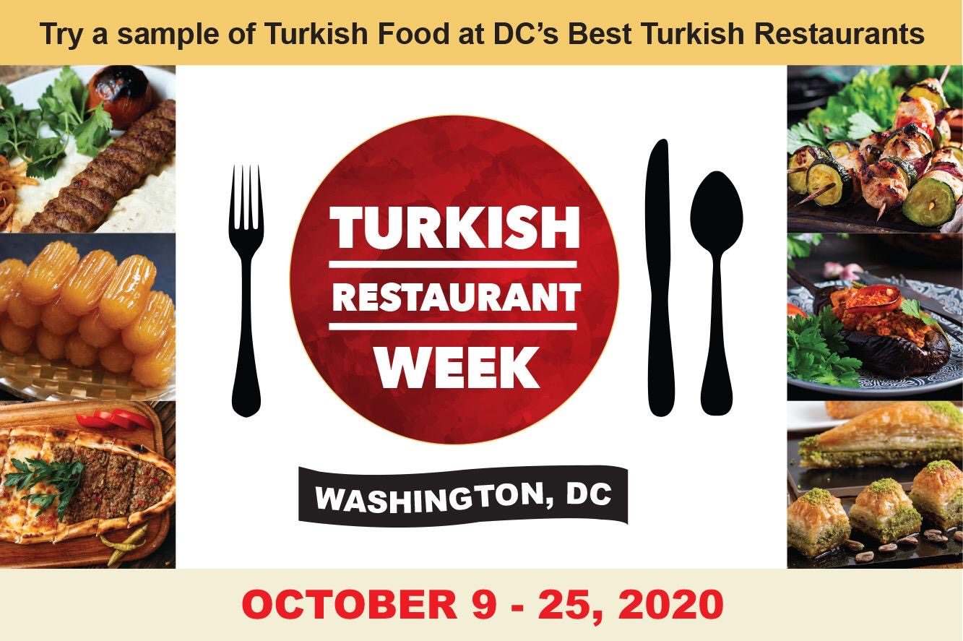

[www.turkishrestaurantweekdc.org](http://www.turkishrestaurantweekdc.org)

*Twitter* @DCTurkRestoWeek

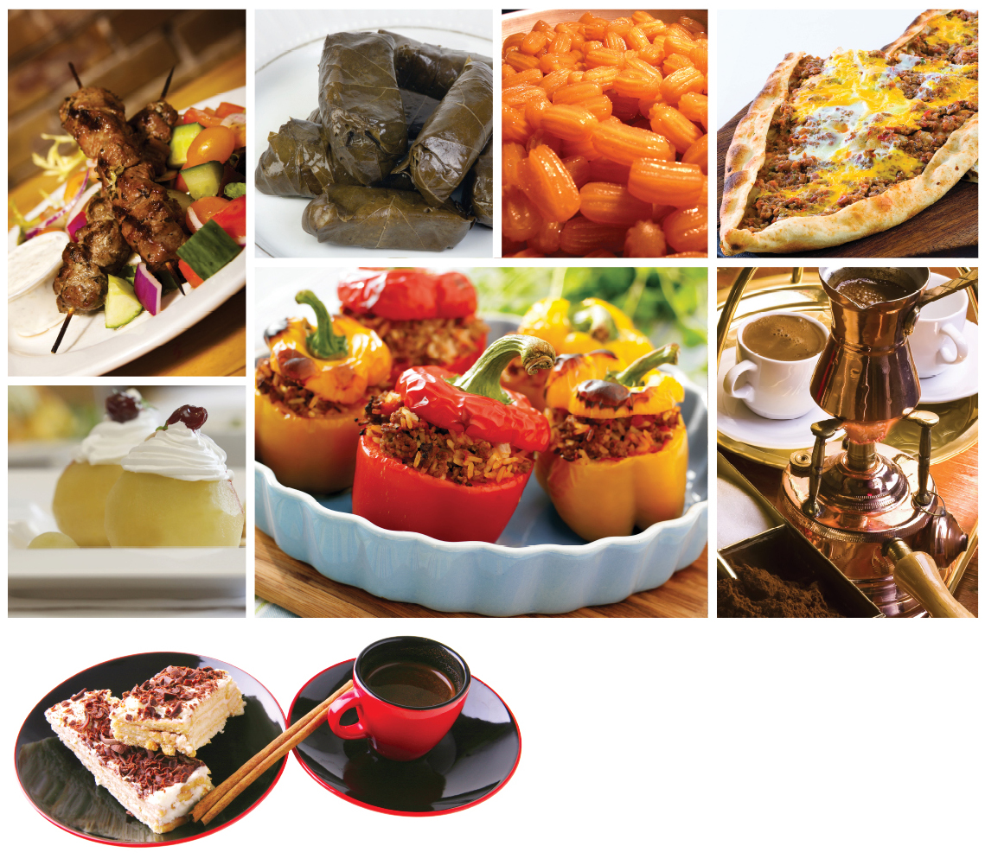

**10th ANNUAL TURKISH RESTAURANT WEEK**

MARCH 9 – 25, 2020

**WASHINGTON, DC**

September 18, 2020

Dear Prospective Restaurant Owner/Manager:

We are excited to announce the 10th Annual Turkish Restaurant Week (TRW) in Washington, DC. This year we are introducing a few changes to the event based on feedback from the restaurant owners and managers:

* TRW will take place in October (October 9-25, 2020) This is a better time to support Turkish Restaurants and enjoy Turkish Cuisine during the Turkish Heritage Month.
* TRW will be organized as a stand-alone event rather than being a part of the Turkish Heritage Month in September: This will allow for more visibility and focus on TRW.
* Special Cuisine and Social Events will be organized to promote TRW: Customers food experience will be enriched with special cuisine and social events in the lead up to and during the TRW.
* The event will be advertised in ATA-DC, Turkish Festival DC and Turkish Restaurant Week websites and social media accounts.

TRW has successfully promoted Turkish cuisine and restaurants in the Washington DC Area since 2009. Organized by the American Turkish Association of Washington, DC (ATA-DC), the event has become a tradition which the Washingtonians cherish. The event promotes not only Turkish cuisine and culture, but also attracts many new customers to Turkish restaurants in the Greater Washington DC Area.

Terms and conditions of participating include:

* As a part of the Turkish Restaurant Week, participating food vendors are required to offer prefix, three-course dinner menu (including salad, meze appetizer, entrée platter or entre choices, and desert) to customers for a special price of $35; and a three-course lunch/brunch menu (meze appetizer, entrée choices, and desert) for a price of $22.
* This special rate will not cover tax, gratuity and beverages.
* The prefix menus will be designed by the participating restaurants, but each menu will be offered with the same name, Turkish Restaurant Week ’20.
* ATA-DC undertakes the advertisement and marketing for this event. A special hashtag **#GOTurkishRestaurantWeek** and media handles will be provided to the restaurants for their use before and during TRW to promote the event.
* The website, [www.turkishrestaurantweekdc.org](http://www.turkishrestaurantweekdc.org) will include information on each participating restaurant and the prefixed menu that is being offered by each restaurant during the restaurant week.
* Restaurants that would like to participate in this event are required to register with ATA-DC, and their names will be put on advertisements and the website.
* Only restaurants that serve Turkish food will be accepted to participate in the Restaurant Week.
* To ensure that the highest quality standard is reached to best promote the Turkish cuisine, the organizing committee keeps the right to final approval of participating restaurants.
* **Due to Covid-19, in order to support Turkish Restaurants in Washington DC area this year there will be no participation fee.**
* The deadline for application is **September 20, 2020**. We need to finalize the list of restaurants by this date to ensure that we can run a successful and timely marketing campaign.
* Should you decide to participate in the Restaurant Week, fill out the form on the last page. We encourage Turkish Restaurants to give $50 gift card to the selected participants on social media.

We do hope that you will participate in the Turkish Restaurant Week and continue to help us turn this event into a wonderful Washington DC tradition such as the Turkish Festival. We look forward to promoting the best of Turkish cuisine with you in the nation’s capital in September!

For questions, please contact restaurant week *coordinators* ***(Fikri Mert Arikan, Atilla Ozdemir, Dilek Cobanoglu, Feriha Istar, Fulya Cevik, Koray Kukrer, Serpil Gulsen, Mina Aydin) at 703-867-6758 or*** [trw@atadc.org](mailto:trw@atadc.org)***.***

Best regards,

|  |  |  |
| --- | --- | --- |
| Sitki Kazanci  President  ATA-DC |  |  |

**2018 Turkish Restaurant Week**

**Application**

**Business Name** __________________________________________________________________________

**Primary Contact** __________________________________________________________________________

**Phone Number** __________________________________________________________________________